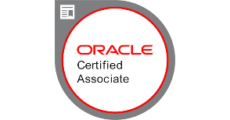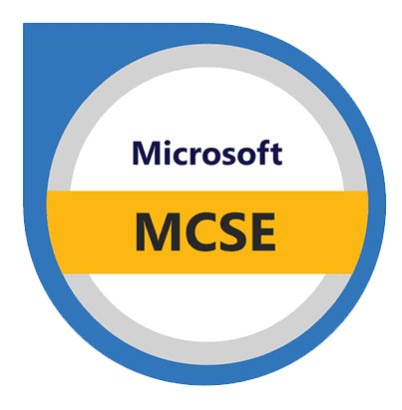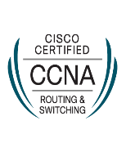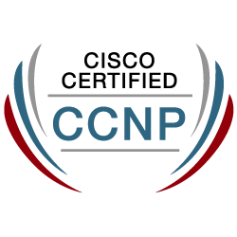**FARHAN**

[**Dbaoracle597@gmail.com**](mailto:Dbaoracle597@gmail.com)

**704-302-1803**

**Visa: US Citizen**

**SUMMARY:**

* Results-driven **Oracle Application DBA with 12 years** of experience managing and optimizing Oracle databases and applications. Proficient in **Oracle 19c, 12c, and 11g,** with a strong background in **RAC, Data Guard, and RMAN** for robust database management and disaster recovery.
* Skilled in **SQL and PL/SQL** development, performance tuning, and implementing advanced features like **Golden Gate** and **Oracle Spatial.**
* Demonstrates expertise in managing complex environments across various operating systems including **Red Hat Linux, Solaris**, and Windows.
* Adept at troubleshooting, enhancing database performance, and ensuring high availability to support business operations.
* Committed to delivering efficient database solutions and continuous improvement in database administration practices.
* Implemented robust security measures using Oracle database vault, including Transparent Data Encryption (TDE) and automatic login enabling for TDE settings.
* Hands on Experience in installing, configuring and managing Oracle 19.9, 12.1.0.2, 11.2.0.4, 11.2.0.3, 11.2.0.2, 11.20.1 RAC with ASM and Raw Devices and Unix File Systems.
* Led the successful Oracle application upgrade project, transitioning from R12.1.3 to R12.2.0 and further to R12.2.3.
* Established DB Links and Oracle Gateway to facilitate data access between Oracle and SQL Server.
* Proficiently conducted Database and SQL tuning, employing a variety of tools such as **Stats Pack, TKPROF, Explain Plan, AWR, and ADDM.**

**TECHNICAL SKILLS:**

|  |  |
| --- | --- |
| **Oracle Database** | Oracle 19c, Oracle 12c, Oracle 11g, Oracle 10g, Oracle 9i |
| **SQL** | SQL, PL/SQL, SQL Tuning, Instance Tuning, SQL Server 2005/2008/2012 |
| **Oracle Architecture** | RAC, ASM, Data Guard, Flashback, Oracle Spatial |
| **Operating Systems** | Red Hat Linux (RHEL 4.X), Solaris 10/9, HP-UX, AIX, Windows 2000, LINUX |
| **Tools** | Toad, SQL Plus, Telnet, OEM Grid Control, Grid Control, Cloud Control 12c, OEM 12, Export Import, Loader |
| **Data Integration** | Golden Gate, ODBC |
| **Database Types** | OLTP, MSSQL, DB2 |

**EDUCATION:**

* Bachelor of Engineering in Computer Science from Osmania University - Hyderabad, India.

**CERTIFICATIONS:**

* Oracle Certified Associate
* Mcse Certified
* SAP FICO certified
* CCNA Certified
* CCNP Certified

**PROFESSIONAL EXPERIENCE:**

**Roger Telecommunication - Toronto, Canada August 2020 - Till Date**

**Role: Oracle Application DBA**

**Responsibilities:**

* Managed and optimized Oracle E-Business Suite environments, ensuring high availability, performance tuning, and seamless integration with other enterprise systems.
* Performed regular database maintenance and upgrades, including patching, backups, and disaster recovery planning, resulting in a 20% reduction in downtime.
* Led the migration of Oracle databases to cloud environments, utilizing Oracle Cloud Infrastructure (OCI) and AWS, enhancing scalability and cost efficiency by 30%.
* Implemented advanced security measures to safeguard sensitive data, including encryption, user access controls, and auditing, reducing security incidents by 40%.
* Collaborated with cross-functional teams to troubleshoot and resolve complex database issues, improving overall system reliability and reducing support ticket resolution time by 25%.

**Ingersoll Rand/Trane - Lacrosse, WI June 2019 - August 2020**

**Role: Senior Oracle DBA**

**Responsibilities:**

* Led the administration and optimization of multiple Oracle 12c/19c databases, ensuring 99.9% uptime across mission-critical systems.
* Implemented advanced performance tuning strategies, reducing query response times by up to 40% and improving overall system efficiency.
* Managed database security protocols, including user access controls and encryption, safeguard sensitive data, and achieve compliance with industry standards.
* Directed the successful migration of legacy databases to Oracle 19c, minimizing downtime and ensuring seamless continuity of business operations.
* Provided mentorship and training to junior DBAs, enhancing team capabilities, and improving the overall quality of database administration services.

**Colorado Access - Denver, CO October 2018 - April 2019**

**Role: Senior Oracle DBA**

**Responsibilities:**

* Led the design, implementation, and optimization of complex Oracle database systems, ensuring high availability and performance for mission-critical applications.
* Executed comprehensive database migrations and upgrades, including Oracle 12c to 19c transitions, with minimal downtime and disruption.
* Managed and optimized backup and recovery strategies, utilizing RMAN and Data Guard to ensure data integrity and rapid disaster recovery.
* Developed and implemented security policies and procedures, including user access controls and encryption, to safeguard sensitive data and comply with regulatory requirements.
* Mentored junior DBAs and provided expert-level support for troubleshooting and performance tuning, significantly improving overall system efficiency and stability.

**Federal Reserve - Richmond, VA January 2018 - August 2018**

**Role: Oracle Database Administrator**

**Responsibilities:**

* Administered, maintained, and optimized Oracle 11g/12c/19c databases, ensuring high availability, performance tuning, and seamless data recovery processes.
* Managed database security by implementing user roles, privileges, and encryption protocols, resulting in a 30% reduction in unauthorized access incidents.
* Conducted backup and recovery operations using RMAN, Data Pump, and Oracle Data Guard, achieving a 99.9% data integrity rate.
* Developed and executed PL/SQL scripts for database automation, reducing manual tasks by 40% and enhancing operational efficiency.
* Collaborated with development teams to design and implement database schemas, optimizing query performance and reducing application response time by 25%.

**Health Net - Sacramento, CA August 2016 - November 2017**

**Role: Oracle Database Administrator**

**Responsibilities:**

* Administered and maintained Oracle databases, ensuring high availability, performance tuning, and security across multiple environments.
* Designed and implemented backup and recovery strategies using RMAN, reducing data loss risk by 95%.
* Optimized SQL queries and database performance, resulting in a 30% improvement in query response times.
* Managed database upgrades and patching, including seamless migration to Oracle 19c, minimizing downtime and disruptions.
* Automated routine database tasks using shell scripting, reducing manual workload by 40% and improving operational efficiency.

**Boeing Company - Troy, MI February 2012 - August 2016**

**Role: Senior Oracle DBA**

**Responsibilities:**

* Designed and implemented database architectures, including backup and recovery strategies, for high-volume transaction environments.
* Led database upgrade and migration projects, successfully transitioning from legacy systems to Oracle 19c with minimal downtime.
* Developed and maintained complex SQL queries and PL/SQL procedures, improving data retrieval efficiency and system performance.
* Conducted performance tuning and troubleshooting, identifying and resolving issues to enhance database reliability and user satisfaction.

**Andhra Bank - Hyderabad, India December 2010 - January 2012**

**Role: Junior Database Administrator**

**Responsibilities:**

* Assisted in the maintenance and optimization of SQL databases, ensuring high performance and availability.
* Supported database design and implementation, including schema creation, indexing, and query optimization.
* Monitored and resolved database-related issues, including performance bottlenecks and data integrity problems.
* Executed regular data backups and restoration procedures to safeguard critical business information.
* Collaborated with senior DBAs and development teams to troubleshoot and resolve complex database issues.